How to configure the Universal Repeater Mode on your Access Point (AP) ?

Product line: wireless question category: Function config

Q: Why we need to set the AP works as Universal Repeater Mode?
A: Sometimes we want to extend the coverage of the wireless network, and keep the wireless devices getting online wirelessly and be in the same LAN range for easy management, Universal Repeater Mode can realize it.

The topology is as below:
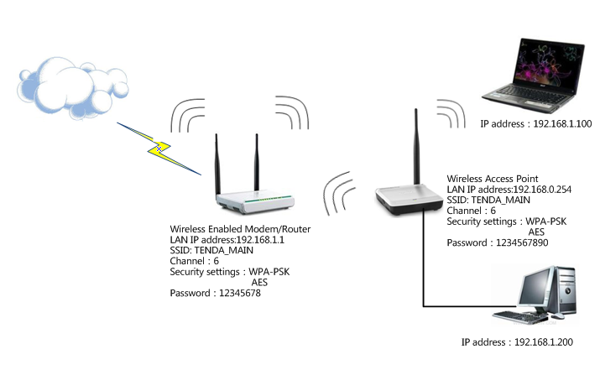
After the settings, your PCs connected to the AP will obtain IP address from the main router and share the Internet connection.

The Steps are as below:
- First we should login to the homepage of AP by typing http://192.168.0.254 in the address bar of the browser.
How to login to the homepage of the AP?
- After login successfully, the following page will appear. Please click on Advanced Settings.
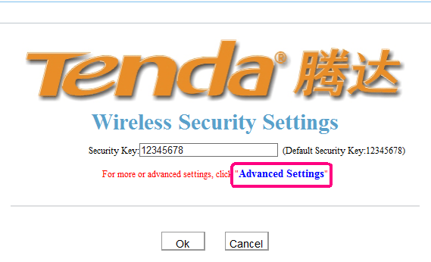
- Configure the wireless basic settings.
Click Wireless settings→Wireless basic settings.
Here you can change the name of your wireless network(SSID) and select certain channel for your AP. You can do the settings as the following picture.
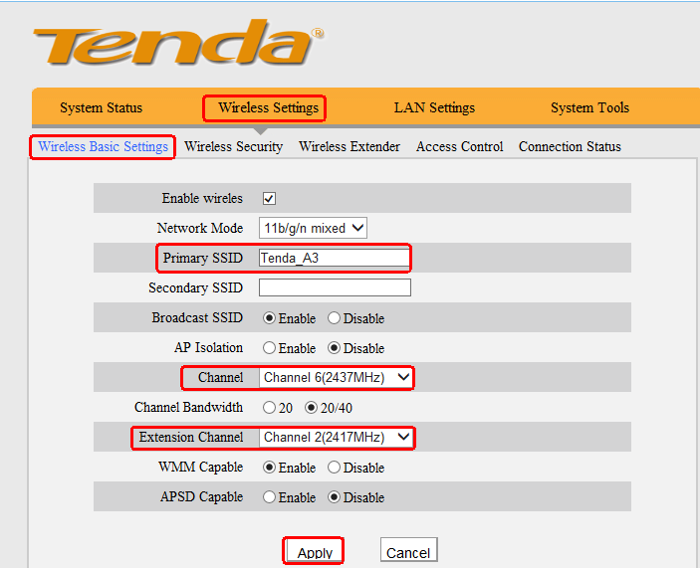
- Configure the wireless security settings.
Click Wireless setting→wireless security, then you can do the settings as the following picture.
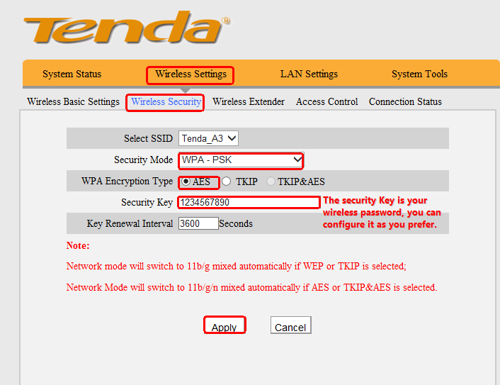
- Configure the Universal Repeater function.
（1）Click Wireless Settings→Wireless Extender. In this page, please select Universal Repeater as the Extender Mode. Hit Open Scan to view the signal of the main router.
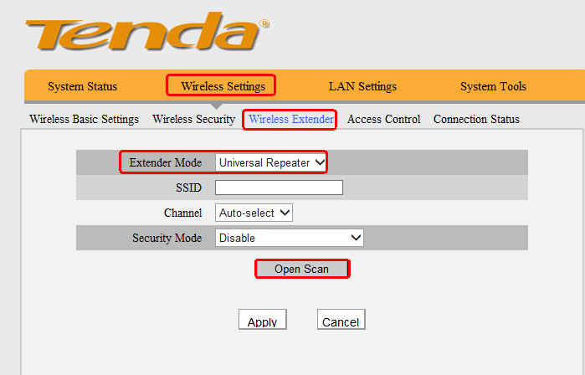
（2）connect to the main router’s signal.
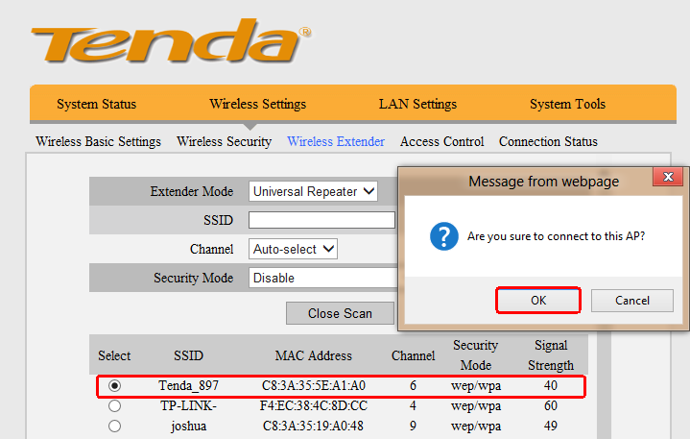
(3) match the security settings to be the same as the main router.
Back to the top page, make sure the security mode, encryption type and security Key all the same with the Uplink router. Remember to click Apply to save the settings.
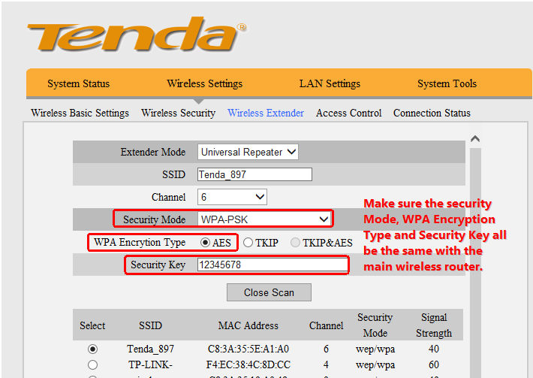

- PC /wireless clients settings.
Go to your PC/ wireless clients, choose obtain IP address automatically and obtain DNS server address automatically. Then you will see the clients connected to the AP can obtain IP address from the uplink router and access to the Internet.
